**Homework #6- Chat Room Protocol**

Notes from Tuesday:

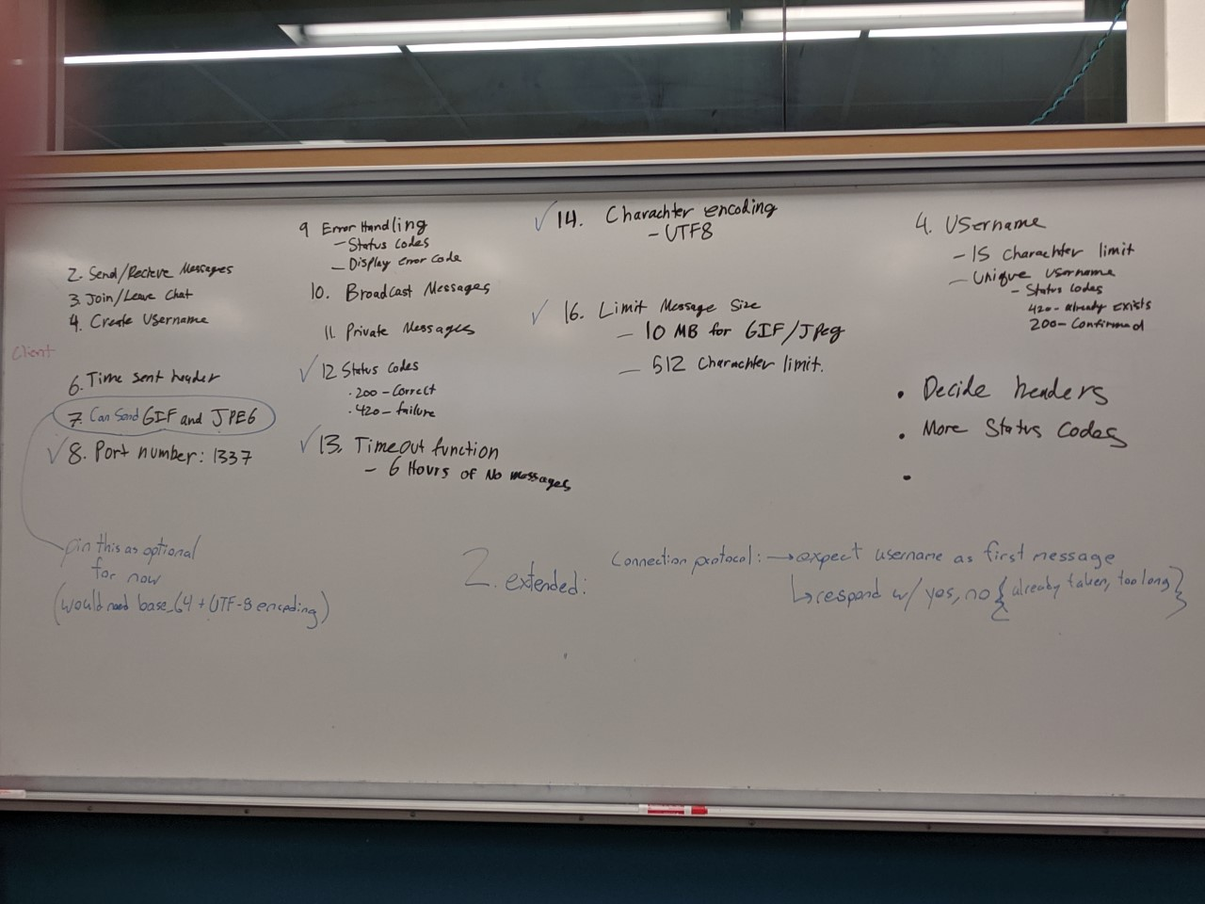

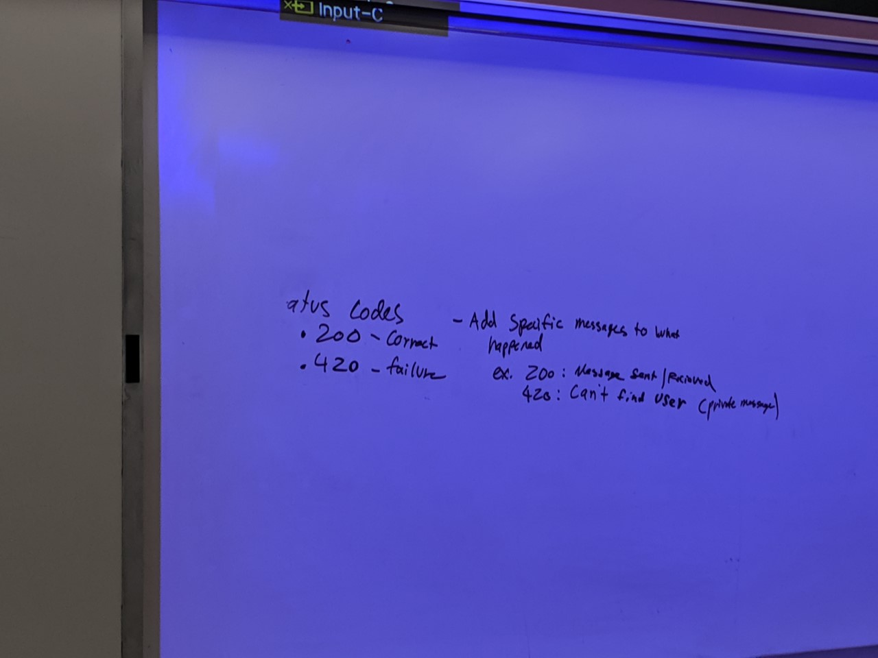

Notes from Thursday:

Message Formatting:

* UT-8 encoding
* Port 1337
* Message limit 512 characters
* Username limit 15 characters

**Commands:**

* JOIN : Join is sent to all other users as a global broadcast, but only after the server has verified that the requested username is valid.
* LEAV: LEAV is sent to all other users as a global broadcast with an empty message content
* PVMG: PVMG is sent to just the specified user
* BDMG: broadcast a message to all users
* STAT: Specifies the server sending a status code back to a client, concerning a message that the client had sent
  + CASE SENSITIVE ALL UPPERCASE COMMANDS

**Message Content Details:**

Command: Just the command + | +

Source: The source username + | +

Destination: a single username on the server, or “all” + | +

Time Sent: yyyy-mm-dd-hh-mm-ss UTC + \r\n +

Content: “message” = your username on a join (15 character)

= “” on leave

= “512 character: on pvmg or bdmg

* \r\n

**Message formating:**

BDMG|cool username|destination user|2019-11-17-08-32-13%\r\n

Hello this is my message\r\n

ON A JOIN (CLIENT TO SERVER) → username and message fields should both be the desired username that you want to join the chatroom with.

**Status code formatting:**

STAT|200

STAT|421

Username allowed characters: a-z, A-Z, 0-9, space, _, -, $, ^, ~, ;

-- new lines cannot be a part of the message

Errors:

200 ok

420 bad username (for joins) (too many characters/taken already)

421 invalid username (for private message)